**Short Term Trading Low Resistance Liquidity Runs Part 1**

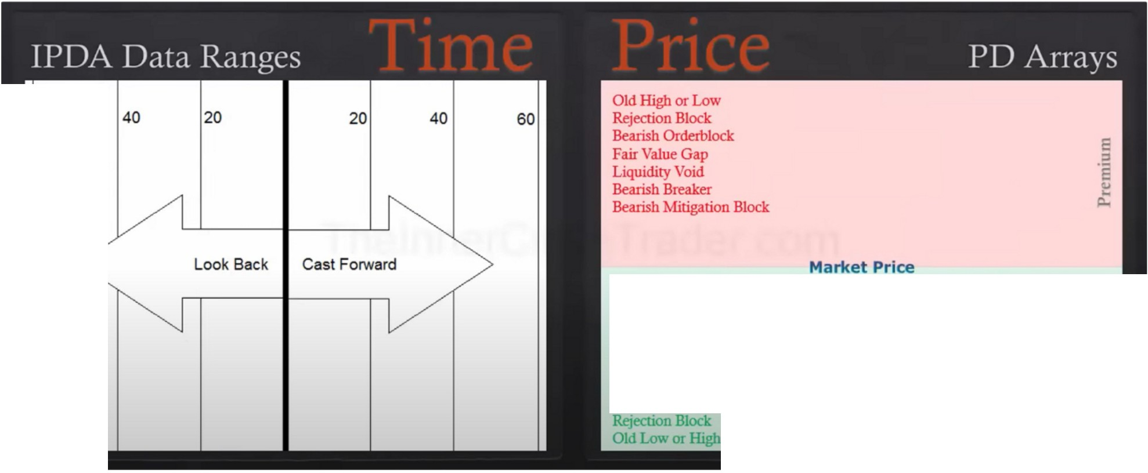

60

Bullish Mitigation Block Bullish Breaker L!quiclity \'aid

Fair Value Gap

Bullish Ordetblock

::

g

i:S

**PD Array Matrix**

Blending time and price

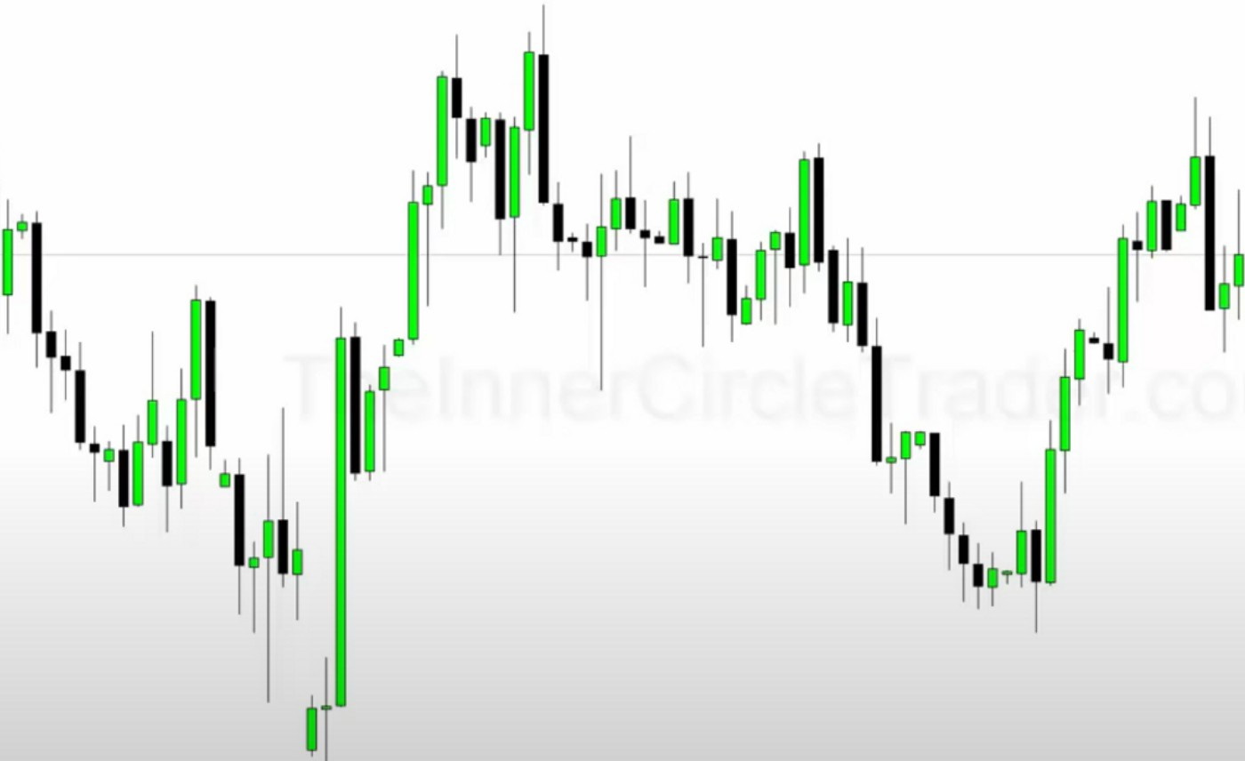

Consolidation profile of the last 60 days

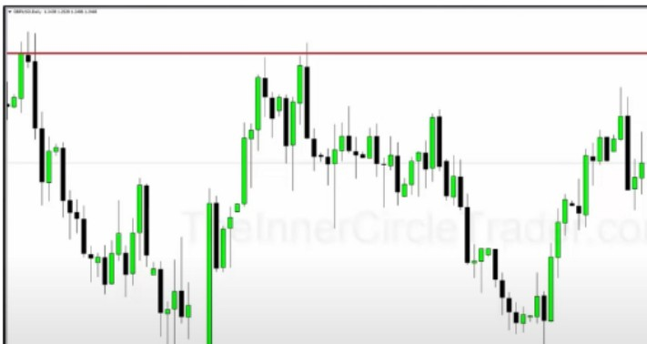

I-

,--

**Define The Range 1n Highest & Lowest Candlestick Bodies** ·-

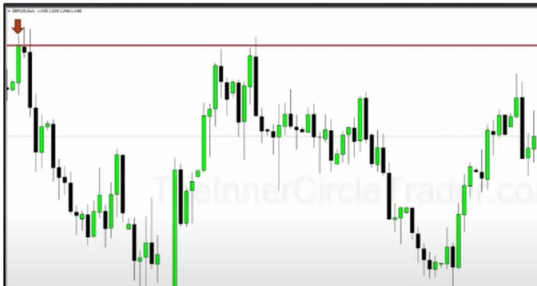

**Define The Range 1n Highest & Lowest Candlestick Bodies**

-

.:

Look at the highest high and lowest low bodies of the candles in the last 60 days, that is our range

,q

1'•1

11 II,

**111**

**1**

--

-

I II

r I···•"·-''r1.,1,111,,

**1 11 1** I

.1i•'l1

1

,•

II

**·1**

**,1-ll**

*'w,.* ll'

--

_,

. ..-

--

-

* **,rl!**

--

--

Use The Fib Tool To Determine SO¾ Of The Range & Note It -

--

-- ---- ·- ...... . & ·•· ... ,.- .. - - .. . . . . ... . .. . . - -

'1,11'1,r.i,.1,

**j·**

-

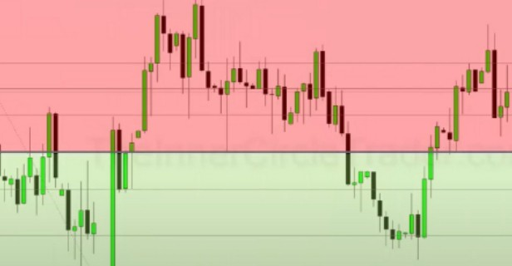

I I

lq

**1,**

Next We Determine The 50 /4 Level Or The Uppc:r & Lo"cr Ranges

Anything above the 50% we look for sells scenarios, either by sell setups or taking profit from longs In the lower portion we look for longs or taking profits from sells

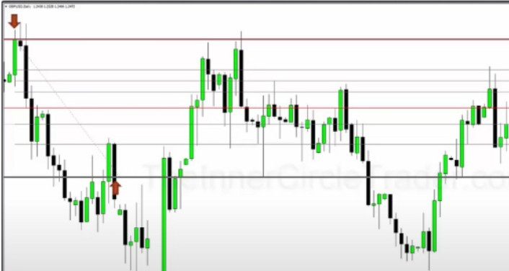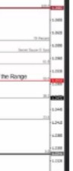

.

Note The so•;, Level or The Upper Range

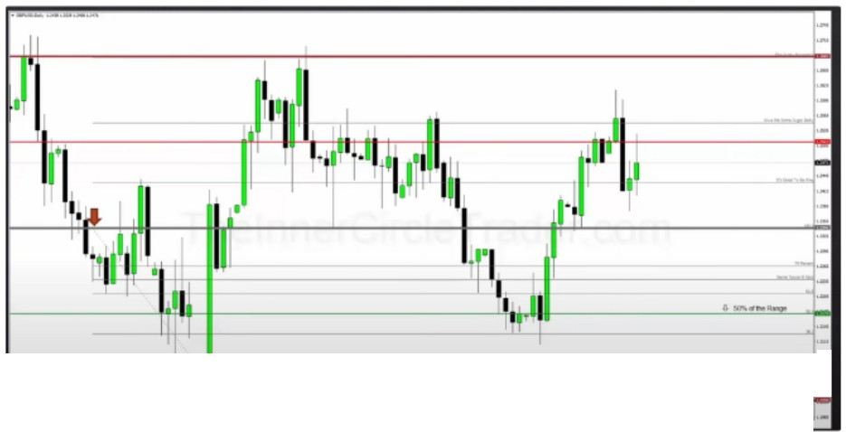

I

•

T Note The 500/4 Lnel or The Lower Range :

We measure the premium part as well with the fibs and note the 50% level. Do the same for the lower range

._. ,.U<J11.-.u-U011

1,,,I

11 *l*

I

**'ttl**

·111

I

il'j·•1 1.,1!1jj

1

I

1·1

I

tj!!

t"'!

L

•

I! I

I

1n!1,.I

**IW'**

,ii._ *NEW:-* d-- D-- ·--

1t

11-. u 11-. 11

**This Gives Us The Consolidation Range** In **Premium** & **Discount**

a-.a, •• ...,

U 11 U- D :r,--· u..., ,_. , u...u *11 ,*

i,...,..,

·-

*u..*■*u.*

. ■

,

* ll'

, , , -■

,

■

, , ■

-

·"*·

··--

=

"*

-

-0, 50% of the Range

I

-·-

·-- -

·-

--

·--

•

I

=

"*



Now we have our consolidation range with premium and discount

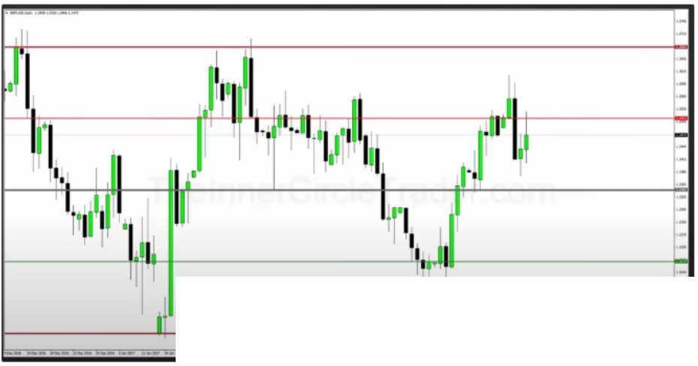

Next We ldeotify The PD Arrays In Each New Range :

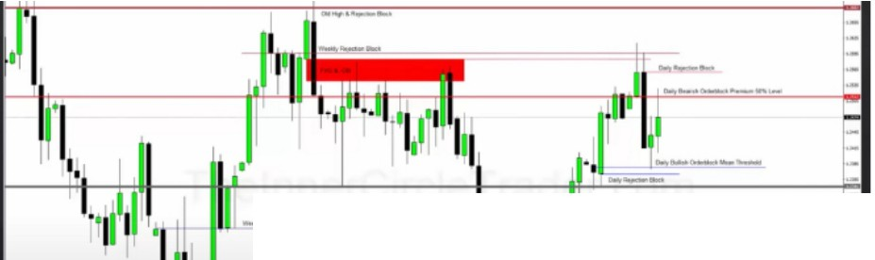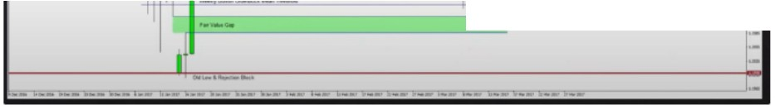

**t"I**

**1**

l-------_JMI -----\ **1,l1-·-------**

All monthly weekly and daily PD arrays

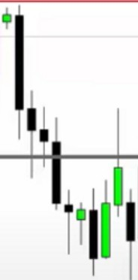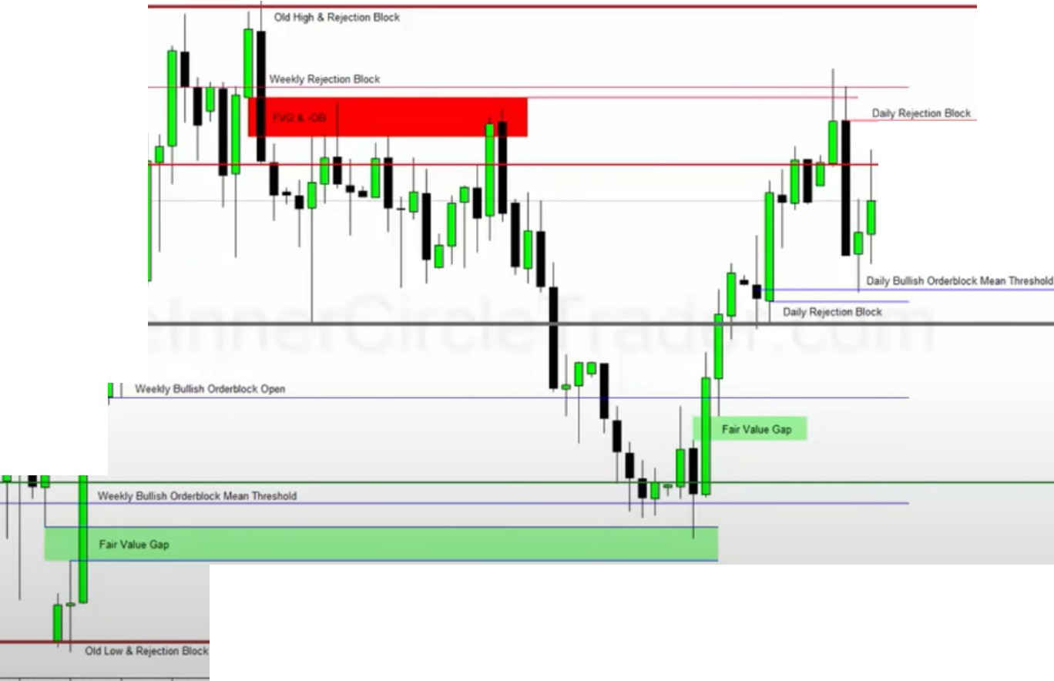

•

**O.,Be..i.Orwblod""-SOY.LMI**

I

**Every Premium** & **Discount Array Provides Setups** In **The PD Array Matrix**

Everything above the grey premium is a good sell, coupled with premium array

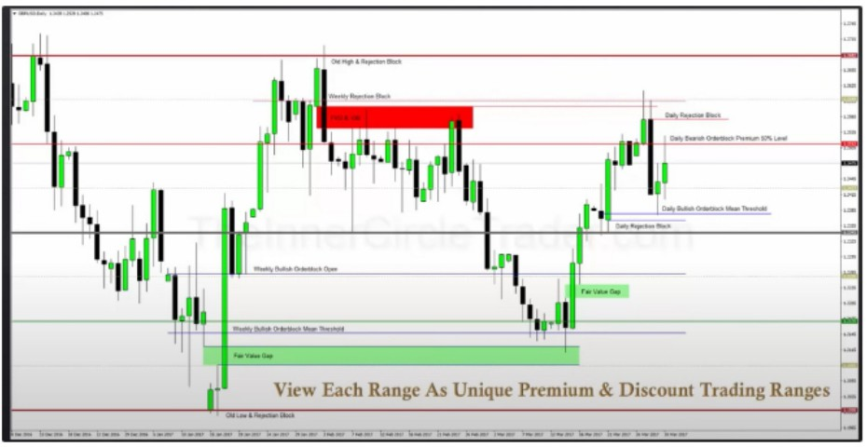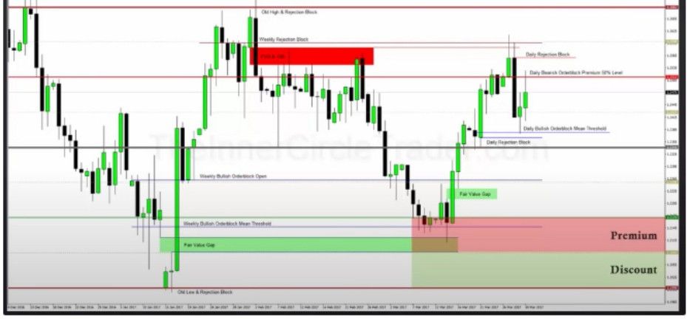We look for a premium array and look for it to trade to a discount array, like the FVG+OB to the weekly bullish orderblock

Everything that forms in the lowest discount in the form of buys is high probability, and we would take profits in the premium of that same range

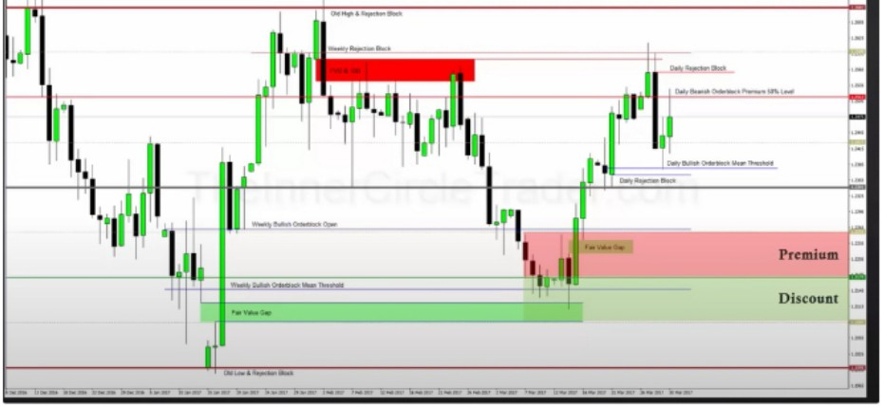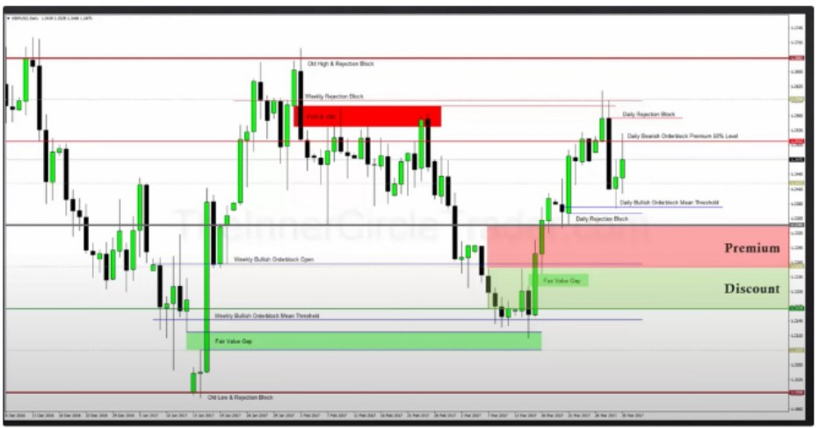

This is an algorithmic way of looking at premium and discount

Now were above the 50% of the total consolidation, we can still take longs but it has to be in discount of this smaller range

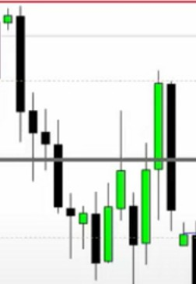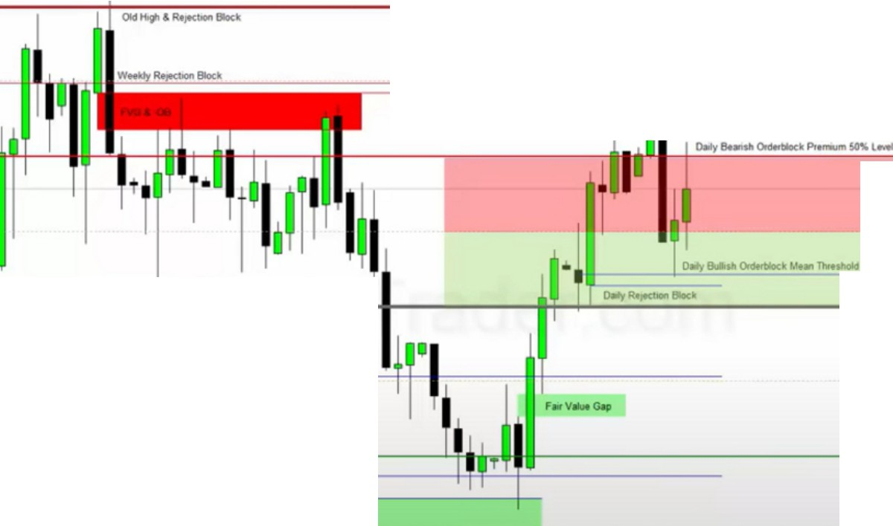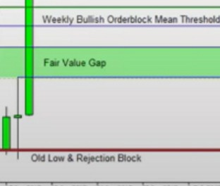

**Premium**

I

**-Discount**

We have quadrants and we divide the quadrants in half as well as were doing here

|  |  |  |  |  |
| --- | --- | --- | --- | --- |
|  | |  | **Premium Discount** |  |
|  |  |
| • |  |
|  |  |
|  | |
|  | |
|  | |  |  |
|  | | | |  |
|  | | | |

Were anticipating the oscilation effect of the consolidation

We can combine this with PD arrays and we can still see how it can go up more eventhough were in the premium part of the overall consolidation. If we have a discount array in the example above in the discount area then we can enter there and exit on a lesser timeframe premium array in the premium area

Now the premium arrays are much more influential as we can see, its the last portion of premium sow its going to have a much more impactful response

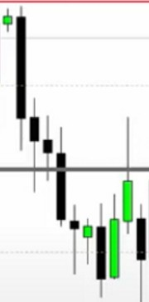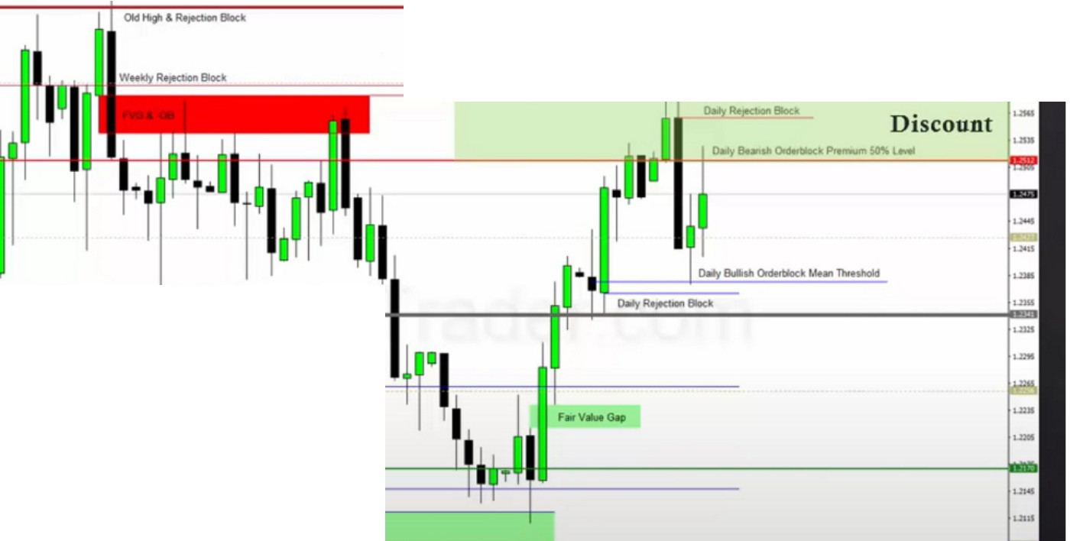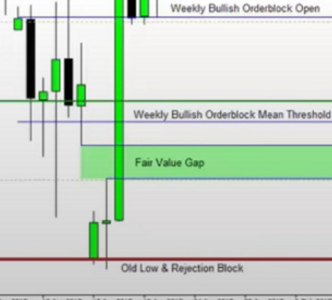

**Premium**

I

•

Were looking for low resistance liquidity runs, from PD array to PD array. And we couple it with 60 days lookback because short term trade excel in the 60 days lookback

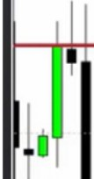Looking at the 20 - 40 and 60 day lookback we can look at the PD arrays where we can exit and take setups in premium or discount

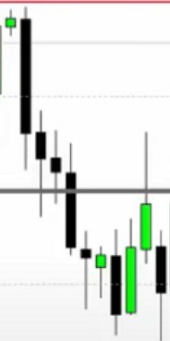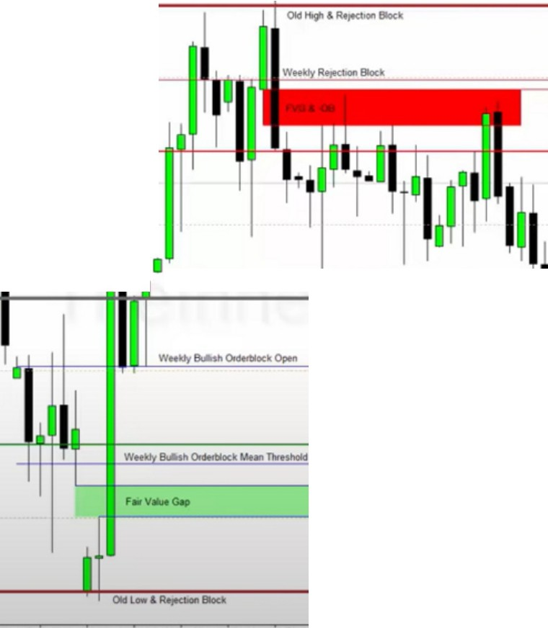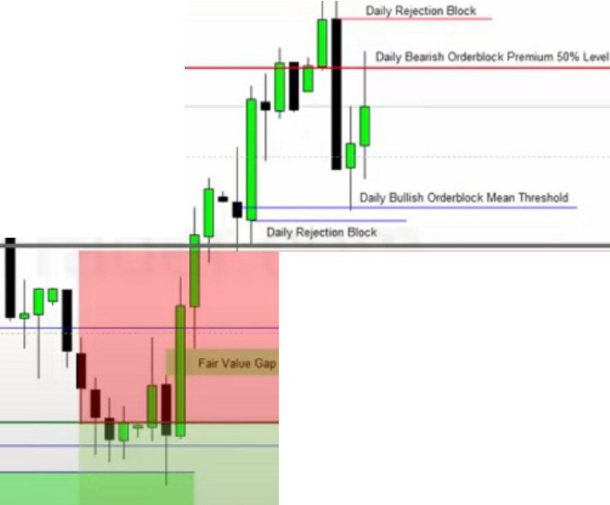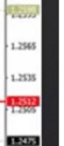

**Premium**

**Discount**

r=

Best buys are going to be there in discount and highest probability targets for sells

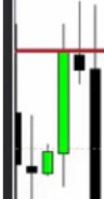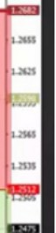

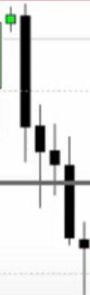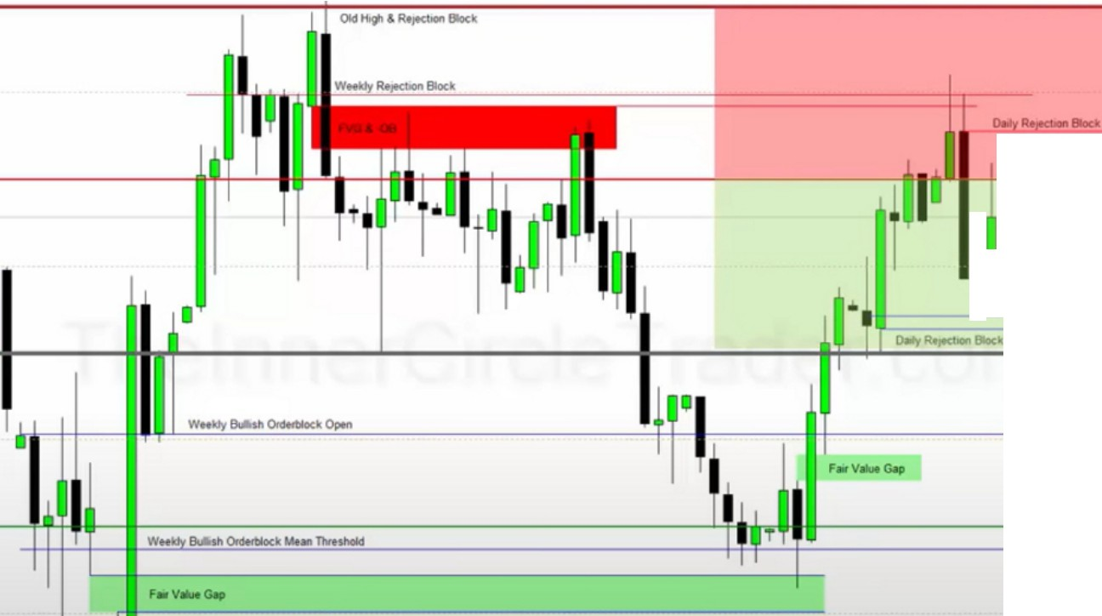

**Premium**

**.....OidldilKk Wllo.......**

**j Discount**

**o.,ya. ClrliNrtiloc•**

tjl!



Highest probability sells are going to be there in premium and high probability targets for longs

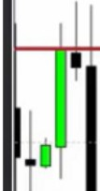One shot one kills are not defines by entering monday and exiting friday, its a couple of days of holding its short term, it can be as little as 1 day and as long as a week

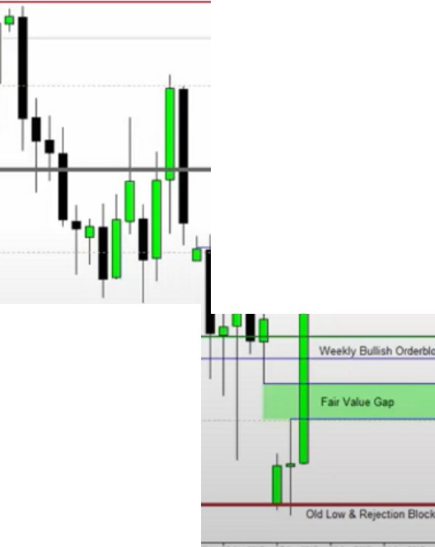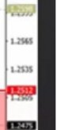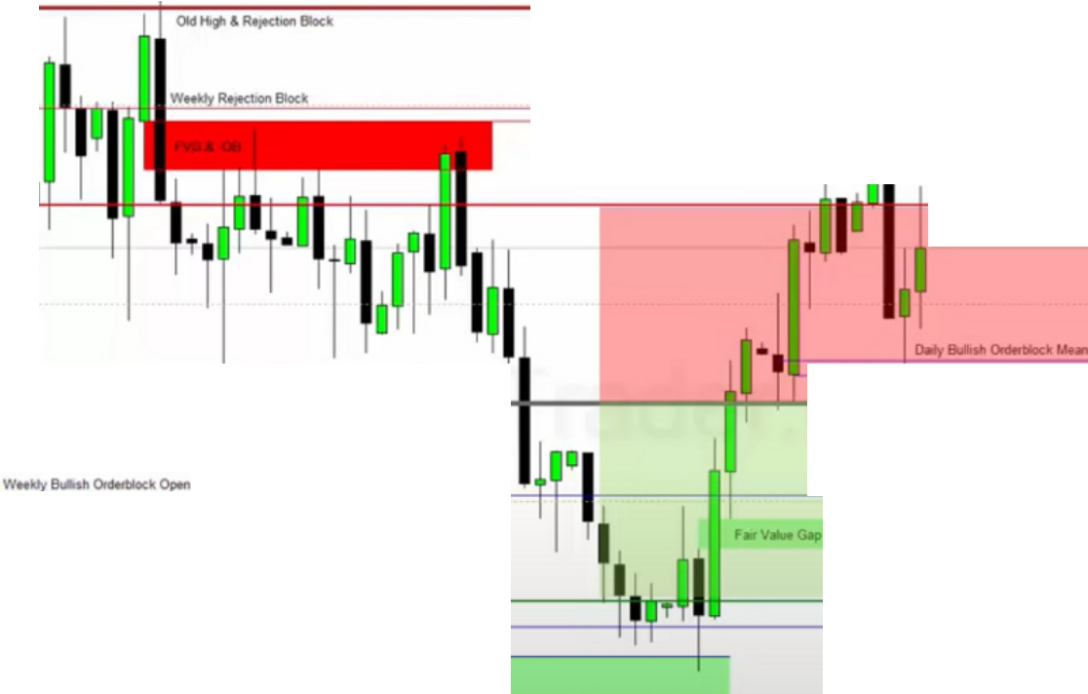

**0-, k 50'll.lMI**

**Premium**

I

...,

**Discount**

This is going to be the area where you get chopped up the most

If you look at a bullish orderblock that has already been traded to then the likelyhood of it being a bullish orderblock falls off. Because the algorithm knows it has already been there

We want to look for a new orderblock that hasnt been traded to in a discount or premium market If youre not strong with bias, then youre going to get chopped up in the middle

The higher you are the better sells and the lower you are the better buys and the easier for buys to play out

Arjo I Twitter, lnstagram I Linktree

Linktree. Make your link do more.

, https://t.co/HhmmTN1fUI

JavaScript is not available.

*"JI* https://twitter.com/arjoio